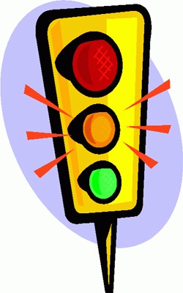

**Information Pack for Transition School Leavers**

***Your guide to accessing the Learning Disability service and other services you may need***



**Contents Page**

Introduction and Medical Care ……………………………………… 3

What is Transition? …………………………………………………… 4

Who we are ………………………………………………………………. 5

Nurses ……………………………………………………………. 6

Occupational Therapy ………………………………….. 11

Psychiatry …………………………………………………….. 12

Clinical Psychology ………………………………………. 13

Dieticians …………………………………………………….. 14

Physiotherapy ……………………………………………... 15

Speech and Language Therapy …………………….. 16

Intensive Support Team ……………………………….. 17

Annual Health Checks ……………………………………………… 18

Hospital Passport ……………………………………………………. 22

Useful contact numbers ………………………………………….. 29

How to refer to the Adults Learning Disability NHS Service ……………………………………………………………………. 30

**Introduction**

Leaving school is a big step for all young people and more so for young people with additional needs.

Many medical and support services also change during transition from school to adult life. You may already be aware of or involved in some of these changes.

This pack is designed to give you all of the information you need to access the adult learning disability NHS service. We have also included some useful contact numbers that you may need.

You may not need all of the information in this pack but we hope it will be a useful resource for the future.

**Medical Care**

Your day to day medical care will be provided by your GP who will look after your basic health needs and medication when needed.

You may need adult specialist health services. You, your GP or someone you know can refer you to the adult learning disability service.

The adult learning disability NHS service works with people who are aged 19 and above, have a diagnosis of a learning disability and are registered with a Birmingham GP.

Information about how to refer to the Adult Learning Disability NHS Service can be found at the back of this information pack.

**What is a learning disability?**

•A significant reduced ability to understand new or complex information or learn new skills

•A reduced ability to cope independently (impaired social functioning) which started in early childhood & has a life-long effect on development.

**What is Transition?**

Transition is the process of preparing, planning and moving

from children’s to adult’s services.

This includes deciding which services are best for you and where you will receive that care.

Transition is about planning and working with you.

We understand that moving away from a team of doctors and nurses that you have been with for many years can be scary but hopefully; by getting involved in the transition process you will feel more confident and happier about the move.

**Becoming an Adult**

Your parents or carers are important in looking after your health and therefore will be able to give you lots of helpful advice.

While you are in the process of transitioning your parents will still be involved in your care and their role is still important.

“Transition is about what happens when a young person leaves school and moves into adulthood. It is about making sure that young people with learning disabilities grow up getting the support they and their families need to live a fulfilling life. Young people with learning disabilities should have the same chances in life as everyone else”

Valuing People Now - (Department of Health 2009)

**Who We Are**

Specialist health services are available for people with learning disabilities in Birmingham.

If you have a learning disability and are 19 years or older, you may require help from us.

We are people who work for the

Our team has:

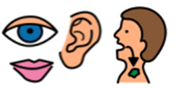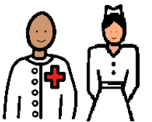

Speech and Language Therapists

Pharmacist

Massage Therapist

Intensive Support Team

Respite care/Short Break Service

Nurses

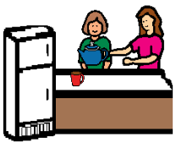

Occupational Therapists

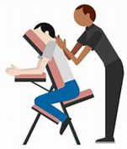

Psychiatrists



Psychologists



Dieticians

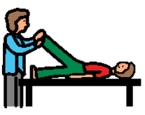

Physiotherapists

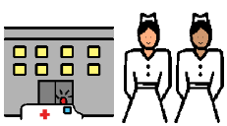**Health Facilitation Nurses**

***What We Know***

People with Learning disabilities may have additional physical and mental health needs.

***What do Health Facilitation Nurses do?***

They support people who experience barriers to accessing health services.

They can give you information to help you to understand your health needs. The information provided is made accessible to suit your level of understanding.

They can help you when you go into hospital if you face any barriers.

We can support you to receive the right treatment at the right time.

**Some reasons to refer to Health Facilitation Nurses**

If you are having difficulties accessing:

* Screening programmes
* Annual health checks
* Health investigations or treatment

They can support you to access the right service at the right time.

**Nutrition Nurses**

***What do Nutrition Nurses do?***

* Look after people who need a feeding tube
* Help you manage your feeding tube
* Train your carers/parents to manage your feeding tube

**Please find Feeding Tube information on the next page**

**Why might you be referred to the Nutrition Nurses?**

* If you need any help to manage your tube feed?
* If your carers need training to manage your tube feed.

**Feeding Tube Problems?**

**Who can you call?**

**The Nutrition Nurse Specialists** (Wendy and Linda), who work for the Learning Disabilities Service. They are the specialists who consider all aspects of care relating to the feeding tube;

* Pre feeding tube assessment and referral for PEG tube placement
* Referrals re feeding tube problems direct to hospital consultants
* Training and education about all aspects of managing your feeding tube
* Post feeding tube placement follow-up
* Hands on clinical care
* Replacing PEG, Balloon and other types of feeding tubes in the community e.g. NG tubes, together with training for carers/agencies etc
* Troubleshooting all problems with feeding tubes e.g. leakage, sore/infected stomas, over granulation, skin problems, broken tube ends/clamps blocked tubes, replacing tubes that have fallen out, pH testing, obtaining aspirate, pump problems or signposting to company nurse.

Hours available; **Monday – Friday, 9am-5pm**. Can be contacted at Greenfields on **0121 466 3900.**

***Note*** *– Staff working hours may be different at present due to the COVID-19 outbreak (as of May 2020).*

**The Nutricia Nurse** who works for the company that delivers the enteral feeding equipment. They have to work within their company guide lines so are unable to offer the same service as the Nutrition Nurse Specialists. They can provide the following service UNDER the direction of the Nutrition Nurse Specialist who has the ultimate responsibility for the patient.

* Pump training and troubleshooting of problems with the pump
* Basic PEG/Balloon tube management training, as delegated to, by the Nutrition Nurse Specialists
* Troubleshooting as above with some limitations as they are not Nurse Prescribers and cannot prescribe treatments.

Hours available; **Monday – Friday 8.30am - 5pm (4pm on a Friday.)** **03452501059** with an out of hours company helpline on **03457623603.**

***Note*** *– The Nutricia Nurse may be unavailable at present due to the COVID-19 outbreak (as of May 2020).*

**If you have a problem / query with the feed going through the tube then contact the dietitian at Greenfields 0121 466 3900**

**Community Nursing**

***What do Community Nurses do?***

* Support people with their physical health
* Support people with their mental health
* Help people with their behaviour management
* Support people to stay living in their home
* Provide people with extra support regarding their health

**Why might you be referred to Community Nurses?**

* If you have behaviours that are hard to manage like shouting, hitting, destroying things, hurting yourself or other people, running away, smearing, problems with police, etc?
* If you have problems with sexual health, understanding sexually appropriate behaviours, sexually harmful behaviours, relationships, etc
* If your behaviours have changed recently
* If you are risk of placement breakdown, subject to physical restraint, restricted activities at home / in the community

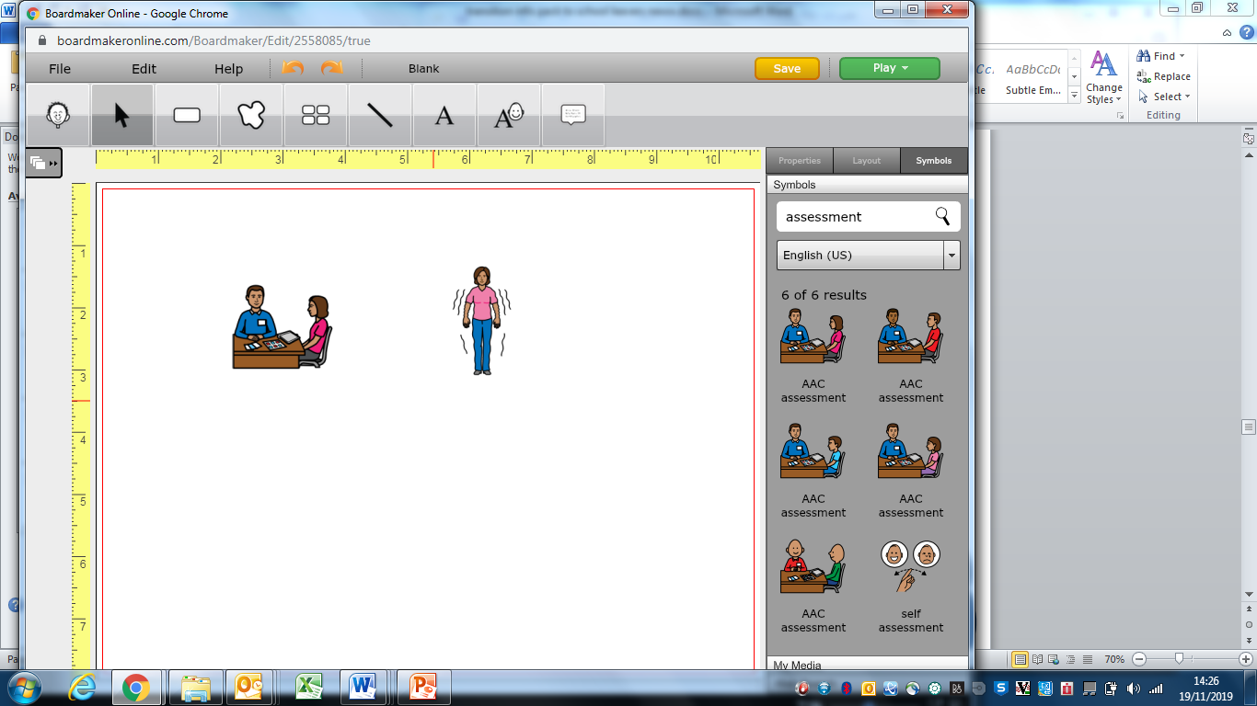**Epilepsy Specialist Nurse**

***What do Epilepsy Specialist Nurses do?***

* Support you with your complex seizures

**Why might you be referred to Epilepsy Specialist Nurses?**

* If you have complex seizures that require specialist services
* If you have had any seizures during the past 24 months with hospital admissions
* Has your epilepsy care plan been written or reviewed over 12 months ago?

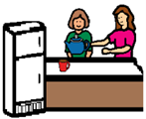**Occupational Therapy**

***The Occupational Therapist can:***

* Help you do the things you want to do, like hobbies
* Help you do activities by yourself
* Help you do things that you enjoy

**Examples of reasons to refer to OT**

* If you find it hard to do activities in your home, e.g. personal care
* If you find it hard to do activities in the community, e.g. shopping, park
* If you do not have enough things to engage with during the day?

**Psychiatry**

***The psychiatrist is a doctor who can:***

* Help with mental health problems, epilepsy, Autism and ADHD
* Prescribe medication to help
* Help keep you safe

*If you want to be seen by a Learning Disability Psychiatrist you will need to ask your doctor (GP) to refer you.*

*If you already have a paediatric psychiatrist you could also ask them to do this for you.*

**Some reasons you might be referred to Psychiatry:**

* If you have mental health problems
* If you have behaviours of concern that cannot be monitored by your GP
* If you have complex epilepsy

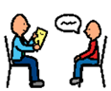**Clinical Psychology**

***Feeling sad? Feeling scared? Feeling angry?***

***A Psychologist can help you.***

Sometimes people shout, hit other people or themselves:

* They will try to understand why this happens.
* They will help you cope and stay safe.
* They work by talking with you.
* They can talk to the people that support you – if you want them to.

**Some reasons to refer to Clinical psychology**

* If you have any signs of emotional distress like changes in your behaviours, moods, tearfulness, anxiety, eating and sleeping patterns, etc
* If your behaviour is a concern for yourself or other people
* If you have experienced a significant traumatic life event that is causing distress some time after it happened

**Dietetics**

***What can the Dietician do?***

* Help you eat the right food for you
* Help you keep a healthy weight
* Help with your tube feeding

**Some reasons why you may need to be referred to a dietician:**

* If you are obese or underweight
* If there are there any concerns about unintentional weight loss
* If you are tube fed?

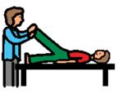**Physiotherapy**

***The physiotherapist can:***

* Find ways to help you walk safely
* Make moving more comfortable
* Help you with your position such as in your wheelchair or bed
* Give you exercises at home
* Help with equipment

**Some reasons you may be referred to physiotherapy**

* If you are unsteady on your feet
* If you are at risk of falling
* If you need special equipment, e.g. wheelchair, sleep system, walking aids or orthotic referral

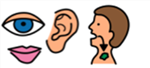**Speech and Language Therapy**

***The speech and language therapist can:***

* Help you with your talking and listening
* Help you understand things
* Help you make choices
* Look at other ways to help get your message across like pictures or signing

***The speech and language therapist can also:***

* Help with your eating and drinking
* Tell you what food and drinks are safe for you
* Help you use the right plates,
* bowls, cups, knives, forks and spoons

**Some reasons you may refer to Speech and Language Therapy for swallowing difficulties:**

* If you have difficulties with your eating and/or drinking
* If you choke and/or cough when eating and/or drinking
* If you use special equipment at mealtimes, e.g. cups, plates and cutlery

**Some reasons you may refer to Speech and Language Therapy for your communication:**

* If you find it difficult to understand information and get your message across
* If you have difficulties communicating with, speech, signing, symbols or objects

**Intensive Support Team**

***The intensive support team can:***

* Help if you have mental health problems
* Help if you are finding things very difficult
* Help you leave hospital safely
* Help you move into your home
* Help you move out of your home

**Some reasons to refer to IST:**

* Deterioration in your mental health that puts you at risk of hospital admission
* If you are at risk of placement breakdown

**Annual Health Checks with your GP**

Did you know that many GP surgeries offer annual health checks for people with learning disabilities? If your GP surgery offers this service you will need to make sure you have been put onto the learning disability register. You will then be invited to receive your health check every year.



The health check is important to make sure you are healthy and you are getting the help that you need.

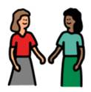

You can bring a person to support you

**What will happen at your health check?**



You will be asked questions about your health like…

* What food do you eat?
* Do you smoke?
* Do you exercise?
* When did you last have your eyes checked?
* Do you have epilepsy?
* Do you drink alcohol?
* What medicines do you take?

**If you agree your doctor may check your;**

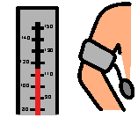 Blood pressure

**What is a health action plan?**

A health action plan is a list of your health issues and actions produced from your health check.

Your health action plan will stay with you and your GP will review it at your annual health check.

Your health action plan will explain all about your health needs and is a good tool to use for people to understand your needs

Your health appointments should be added to your health action plan and reviewed by the health professionals involved

 Weight

 Height

 Eyes

 Ears

 Heart

 Urine sample



Medication you take

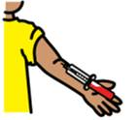

Will ask you for a blood test

If you do not want a blood test you can still have a health check but some health problems may be missed.



**Bring your Health Action Plan with you** **If you are worried about your health check you can speak to your doctor**

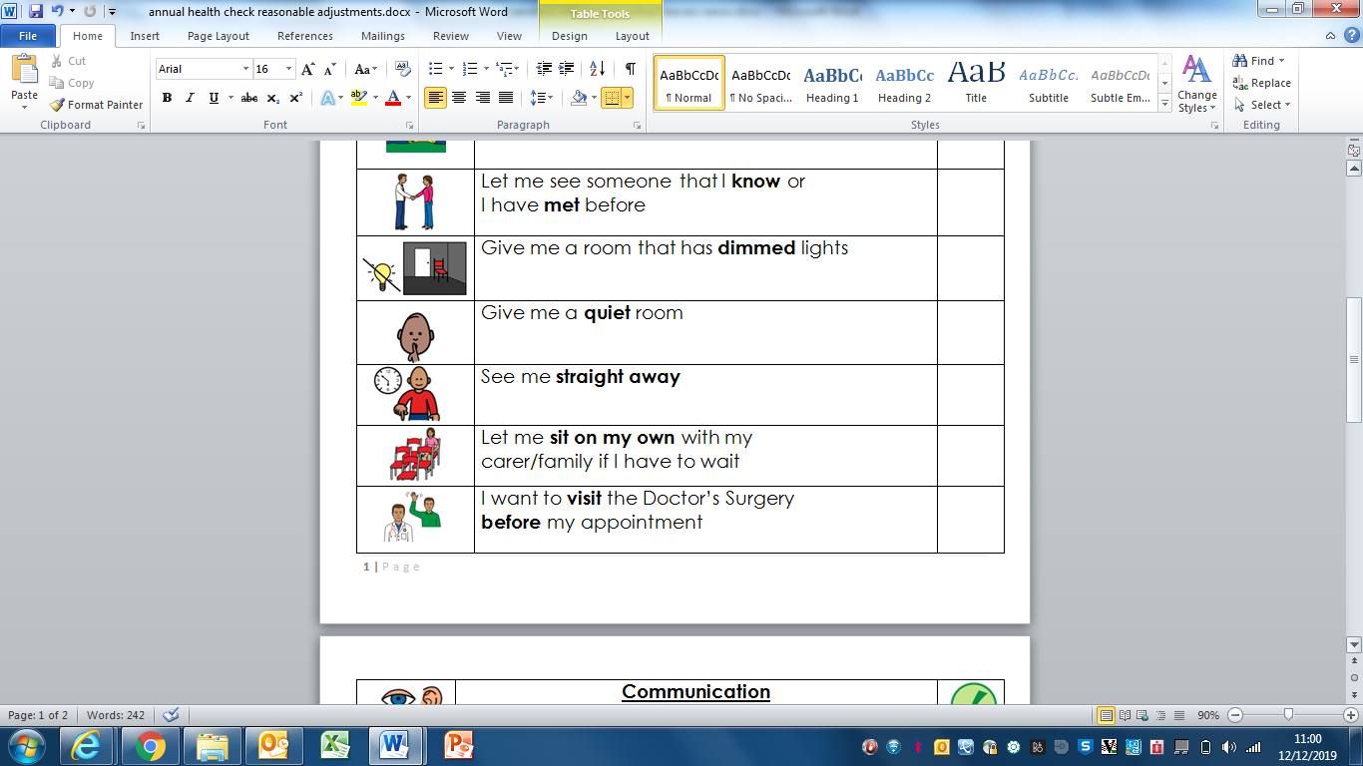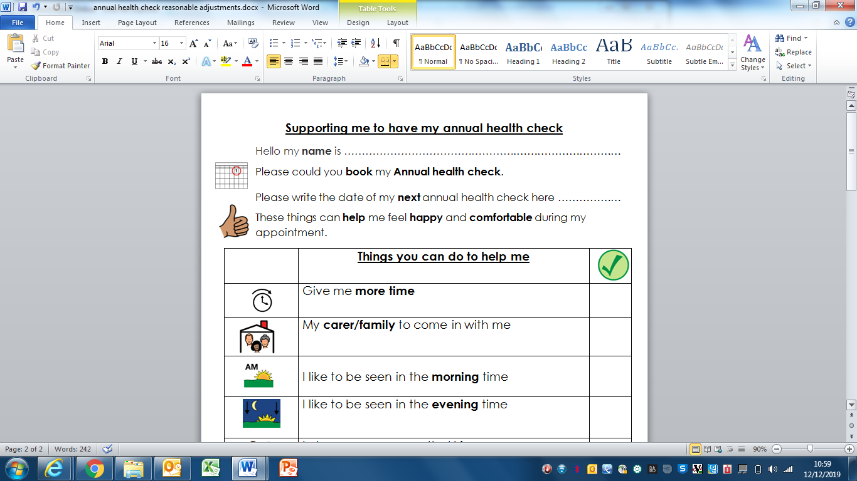

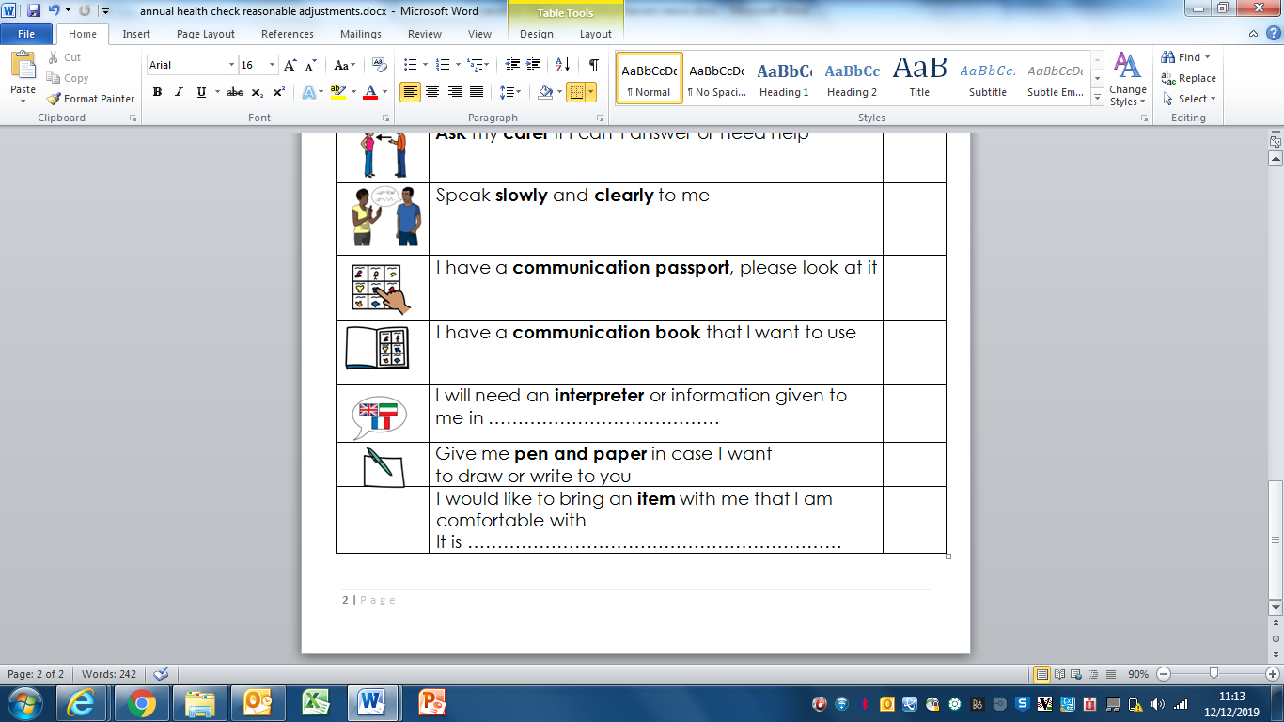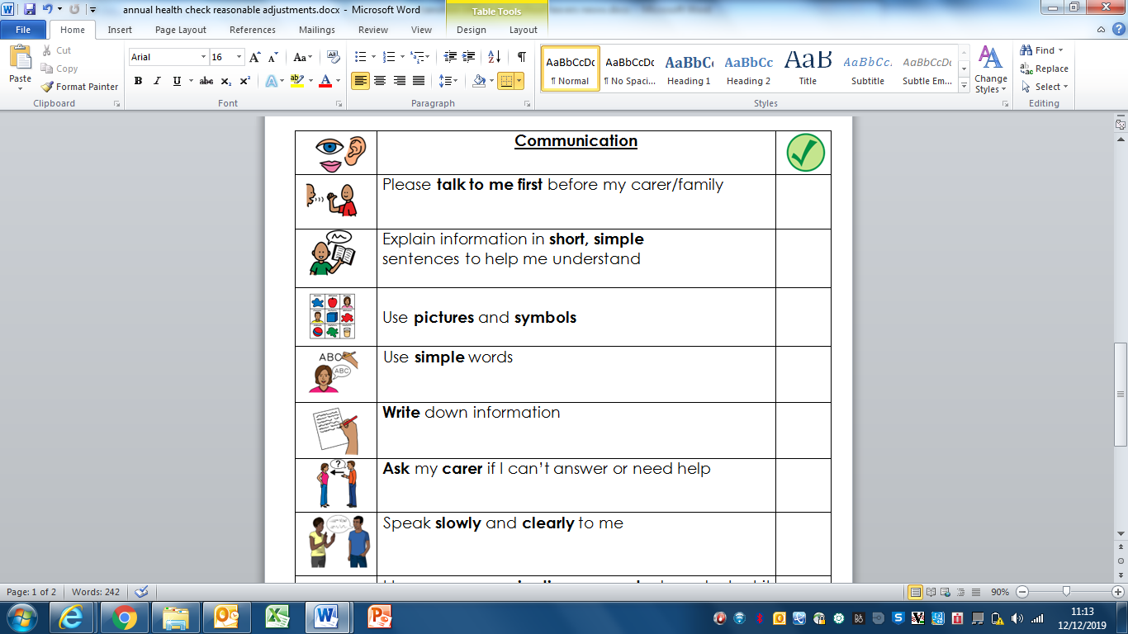

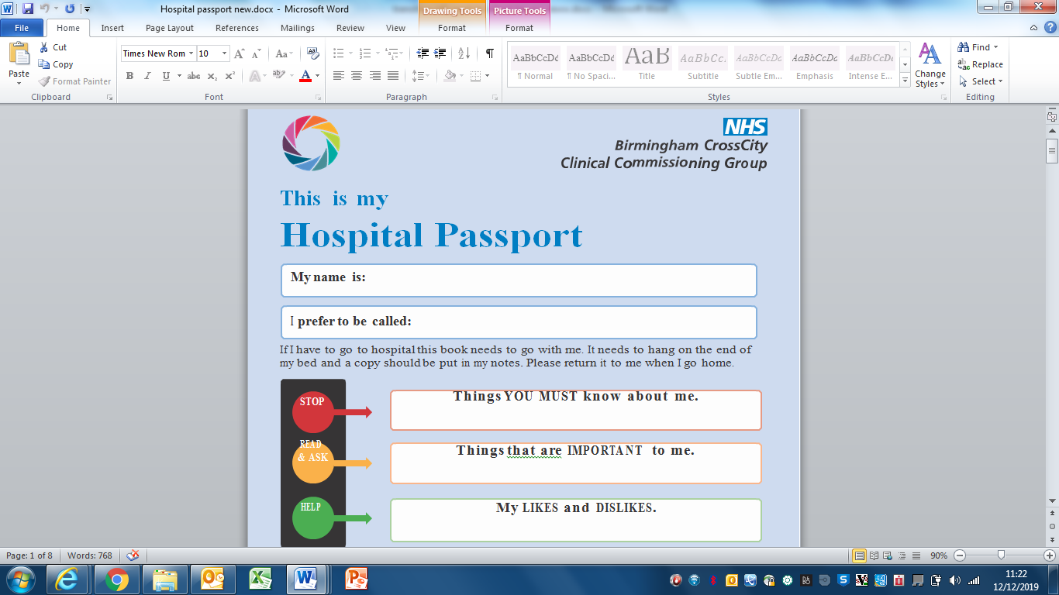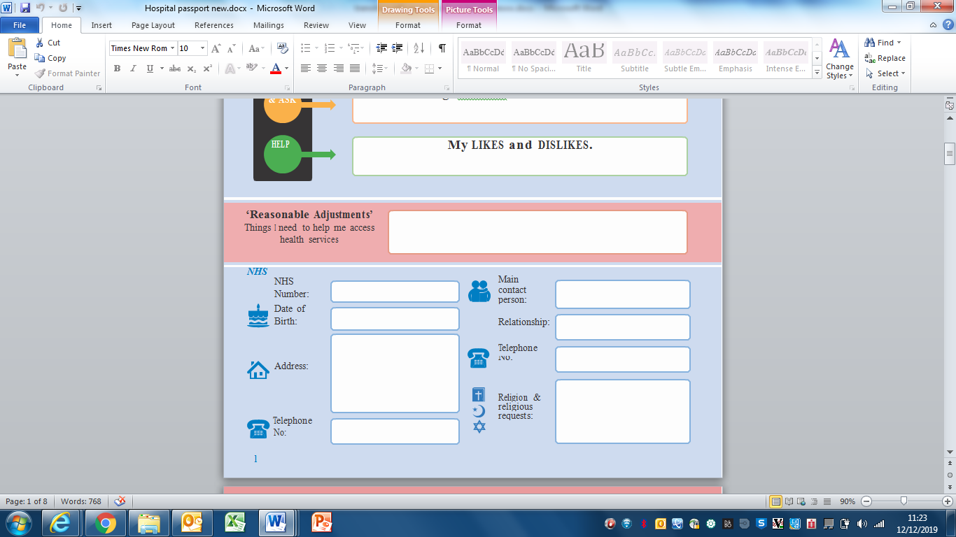

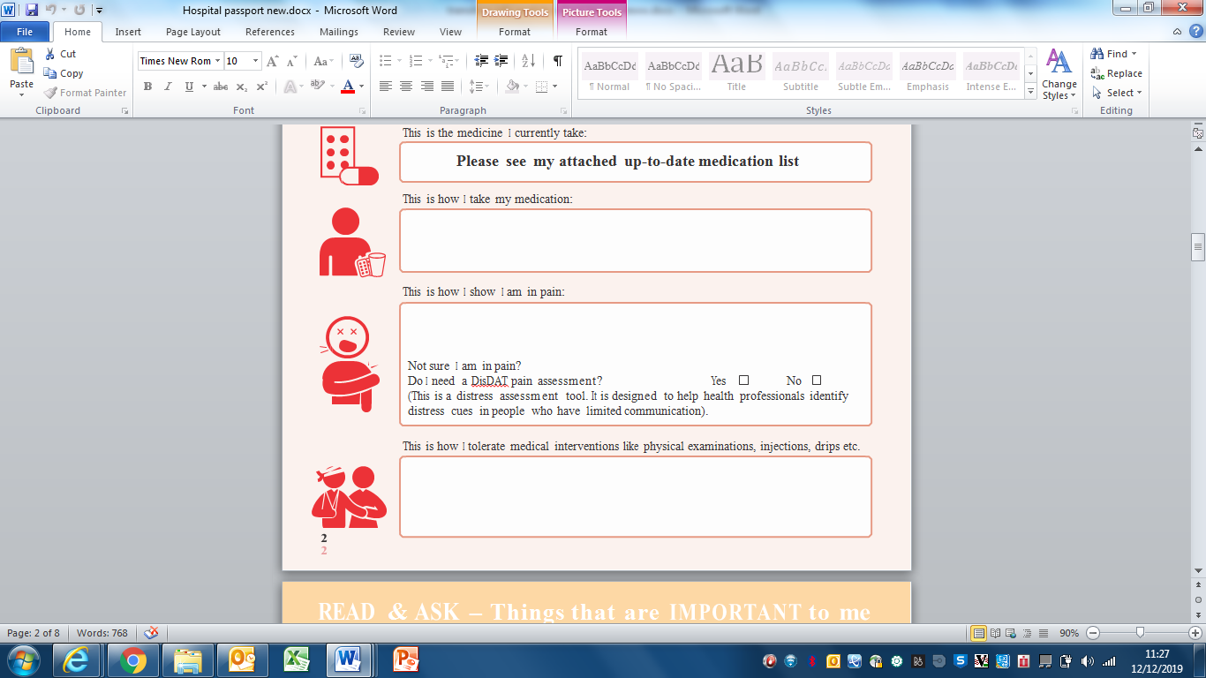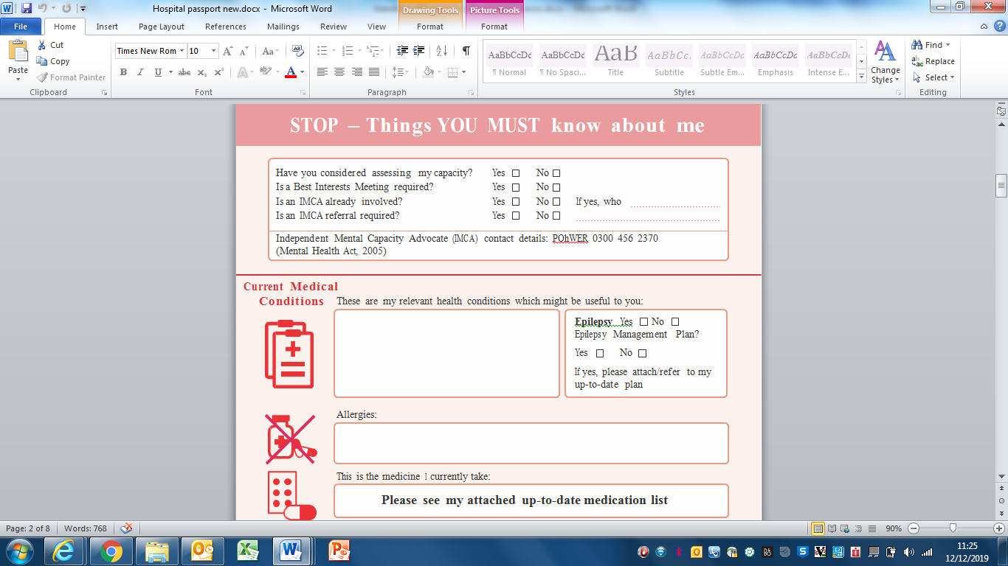

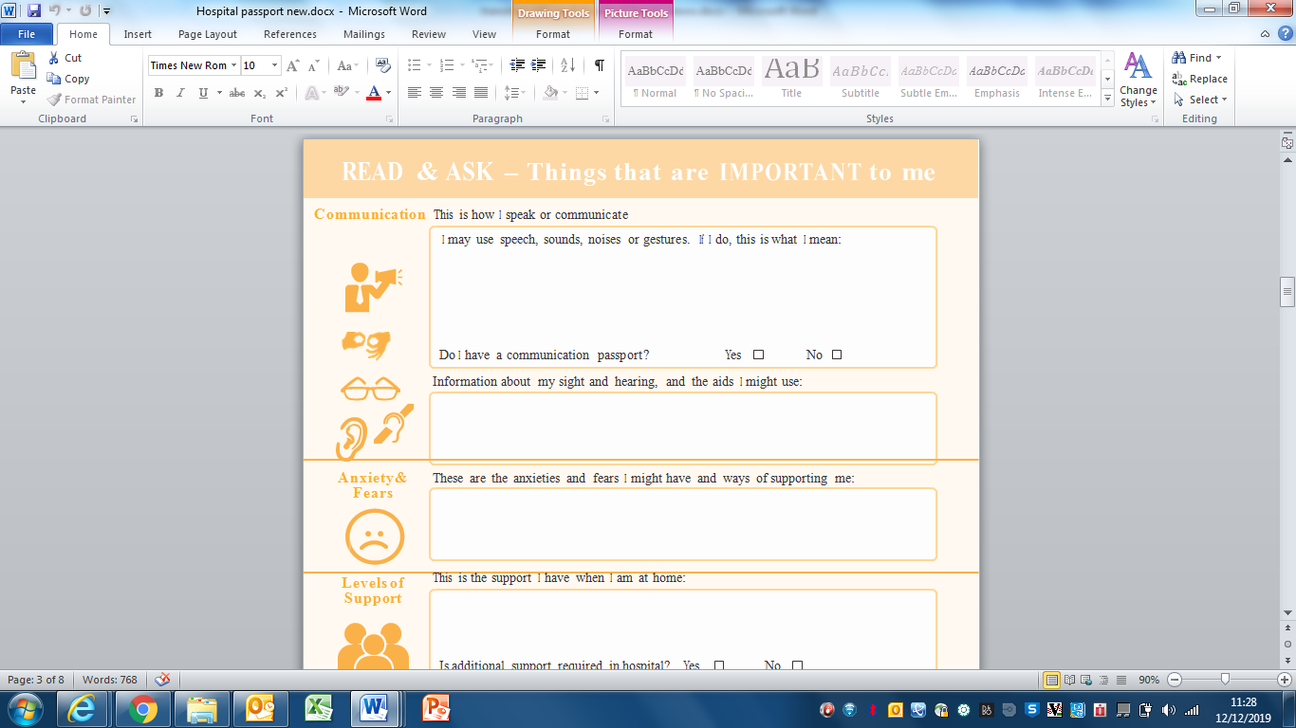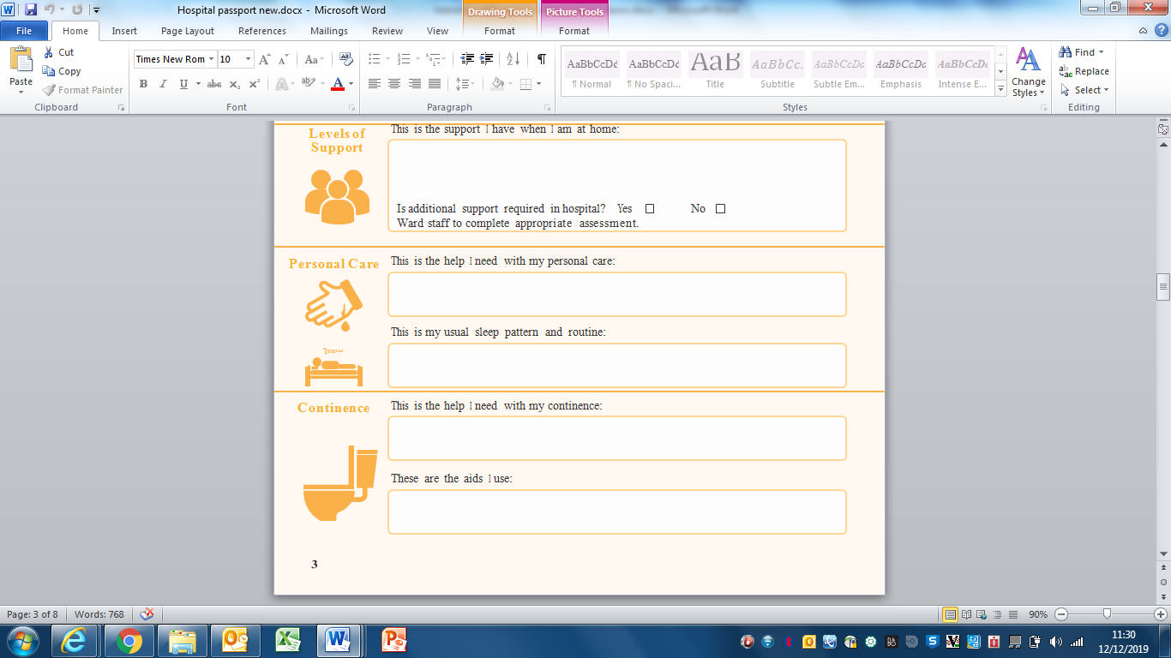

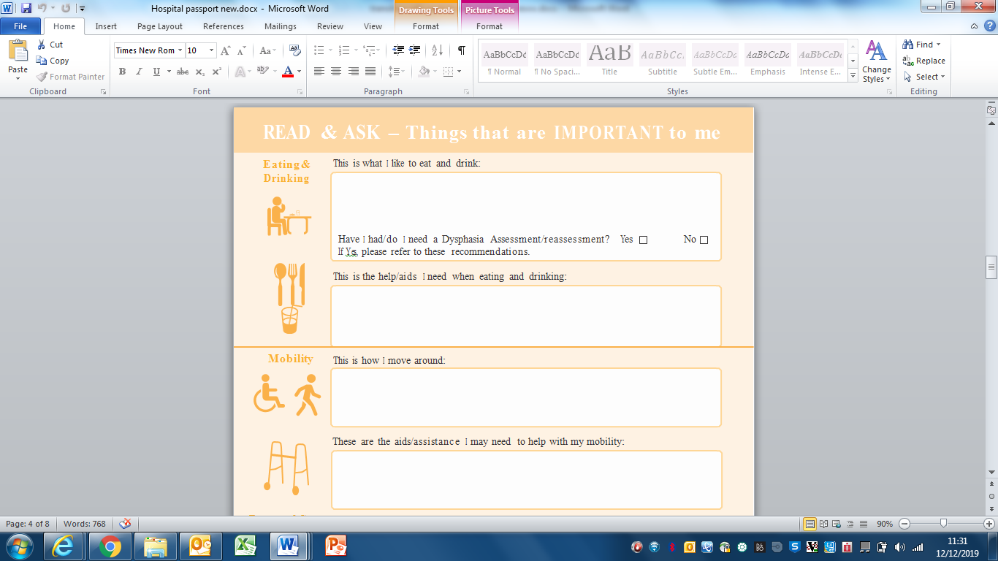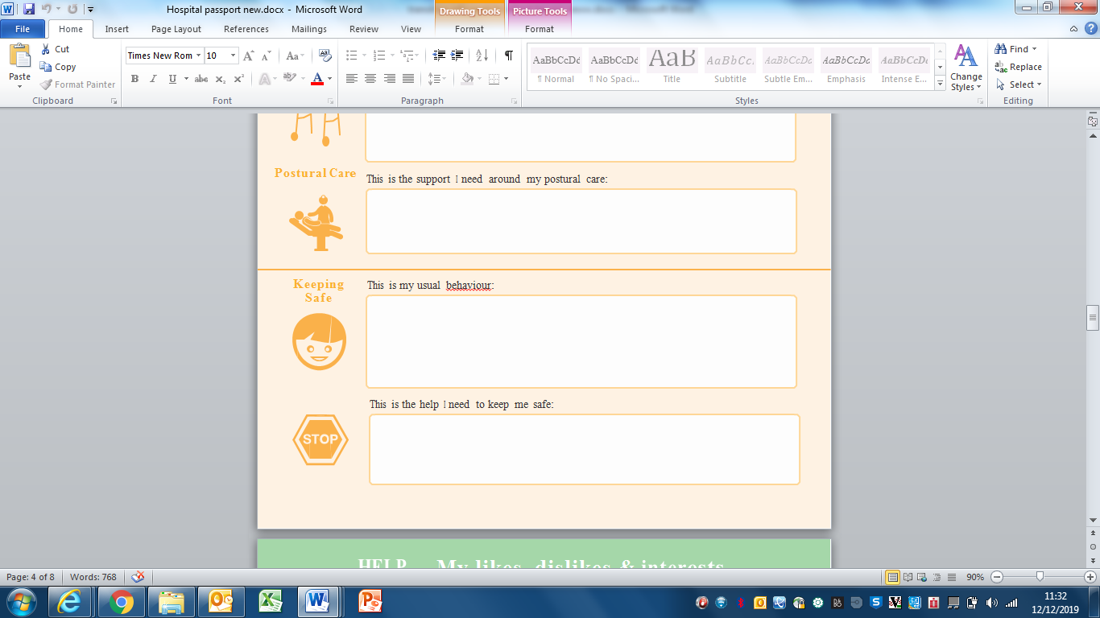

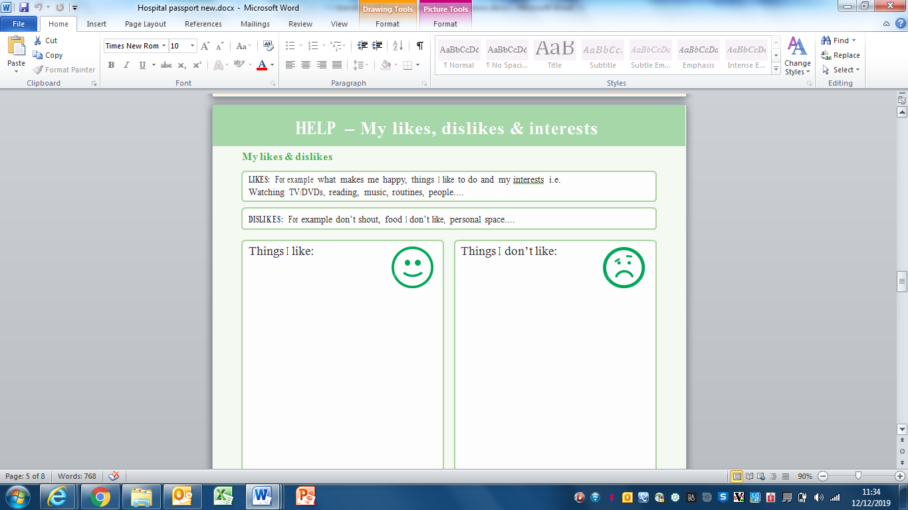

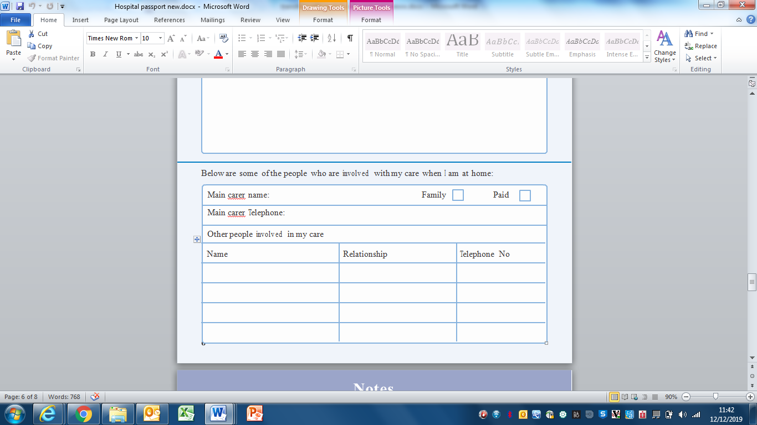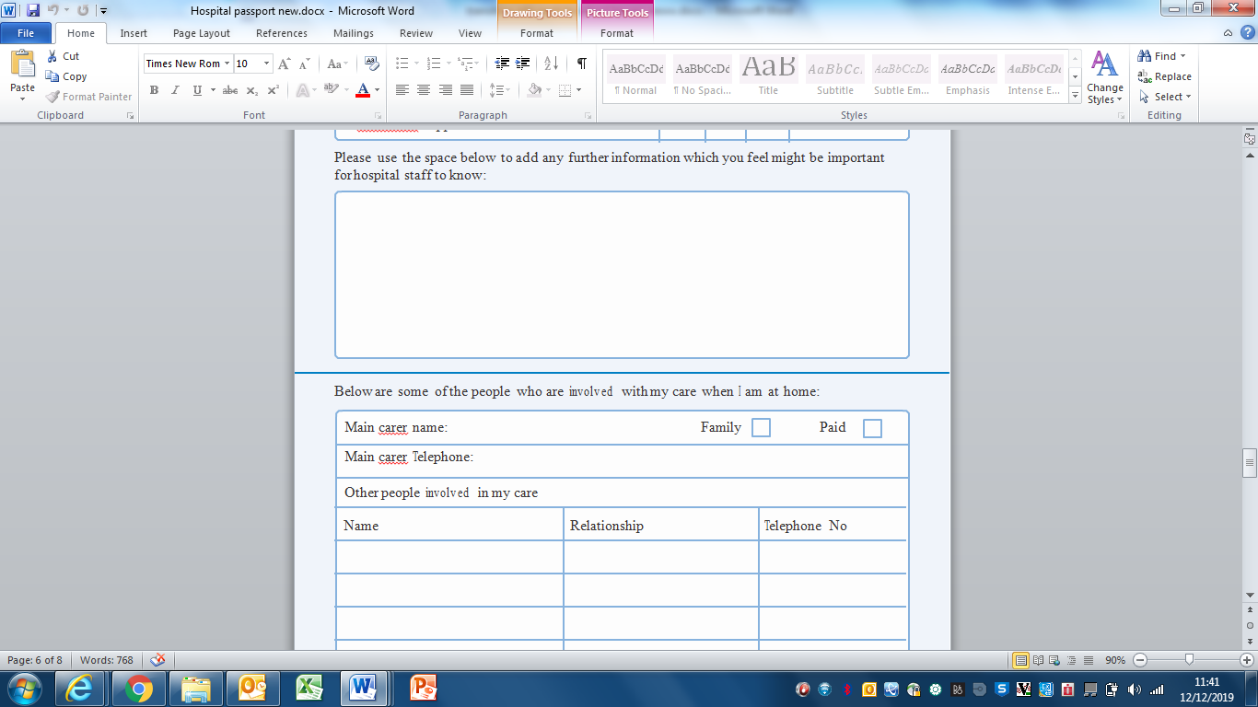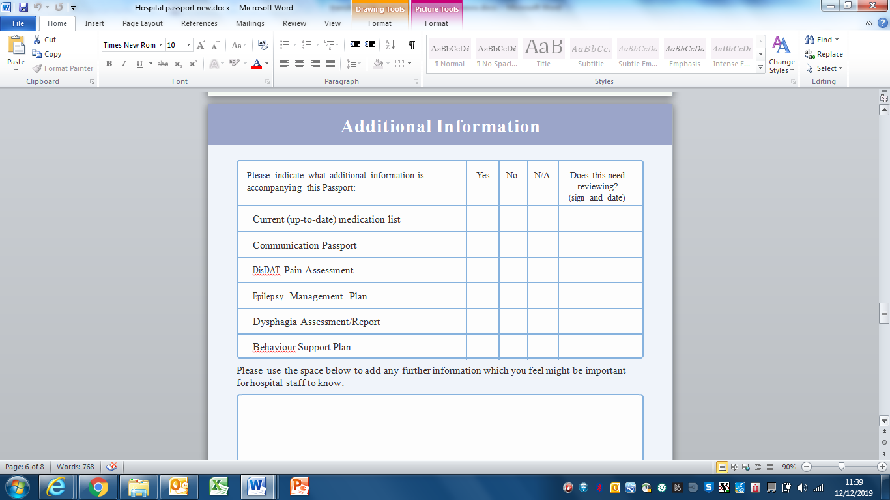



**Useful Contact Numbers**

**How to refer to the Adult Learning Disability NHS Service**

Anyone can refer to the Adult Learning Disability NHS Service by completing our referral form on the next page, and sending it to;

**LD Referrals**

**Greenfields**

**30, Brookfield Road**

**Kings Norton**

**Birmingham**

**B30 3QF**

Or email to: **BCHNT.LDreferrals@NHS.net**

You can also call **0121 466 4980** to speak to our Single Point of Access to make a referral





**Accessible Referral Form**

|  |  |  |  |
| --- | --- | --- | --- |
| \\apollo\citrixhome$\Home\hope.howard.APOLLO\Downloads\Form Print Name.png | Name |  | |
| Image result for nhs | NHS number |  | |
| \\apollo\citrixhome$\Home\hope.howard.APOLLO\Downloads\Birth Date.png | Date of birth |  | |
| \\apollo\citrixhome$\Home\hope.howard.APOLLO\Downloads\Address Post Code.png | Address |  | |
| \\apollo\citrixhome$\Home\hope.howard.APOLLO\Downloads\Dont let strangers.png | Visit issues e.g. Access risk, alerts |  | |
| \\apollo\citrixhome$\Home\hope.howard.APOLLO\Downloads\Friendship 1.png | Ethnicity  (Please tick one) | White  British  Irish  Other white background  Mixed  White and Black Caribbean  White and Black African  White and Asian  Other mixed background  Not stated  Not stated | Black or Black British  Caribbean  African  Other black background  Other Ethnic Categories  Chinese  Any other ethnic category  Asian or Asian British  Indian  Pakistani  Bangladeshi  Other Asian background |
| \\apollo\citrixhome$\Home\hope.howard.APOLLO\Downloads\Gender Male Female.png | Gender  (Please tick one) | Male  Female  Other  Prefer not to say | |
| \\apollo\citrixhome$\Home\hope.howard.APOLLO\Downloads\Languages.png | Language |  | |
| \\apollo\citrixhome$\Home\hope.howard.APOLLO\Downloads\Language interpreter.png | Do you need an interpreter? |  | |
| \\apollo\citrixhome$\Home\hope.howard.APOLLO\Downloads\Telephone Red.png | Telephone Number |  | |
| \\apollo\citrixhome$\Home\hope.howard.APOLLO\Downloads\Blow nose tissue.png | Allergies / sensitivities  (for example, hay fever, food, light, loud noises) |  | |

**Carer Information**

|  |  |  |
| --- | --- | --- |
| \\apollo\citrixhome$\Home\hope.howard.APOLLO\Downloads\Form Print Name.png | Name |  |
| \\apollo\citrixhome$\Home\hope.howard.APOLLO\Downloads\ID Badge 2.png | Designation/  relationship to the person |  |
| \\apollo\citrixhome$\Home\hope.howard.APOLLO\Downloads\Address Post Code.png | Address |  |
| \\apollo\citrixhome$\Home\hope.howard.APOLLO\Downloads\Telephone Red.png | Telephone Number |  |
| \\apollo\citrixhome$\Home\hope.howard.APOLLO\Downloads\Email.png | Email |  |

**Next of Kin Information e.g. Mum, Dad, Brother**

|  |  |  |
| --- | --- | --- |
| \\apollo\citrixhome$\Home\hope.howard.APOLLO\Downloads\Form Print Name.png | Name |  |
| \\apollo\citrixhome$\Home\hope.howard.APOLLO\Downloads\Address Post Code.png | Address |  |
| \\apollo\citrixhome$\Home\hope.howard.APOLLO\Downloads\Telephone Red.png | Telephone Number |  |
| \\apollo\citrixhome$\Home\hope.howard.APOLLO\Downloads\Email.png | Email |  |

 **GP information (Must be a Birmingham GP)**

|  |  |  |
| --- | --- | --- |
| \\apollo\citrixhome$\Home\hope.howard.APOLLO\Downloads\Form Print Name.png | Name |  |
| \\apollo\citrixhome$\Home\hope.howard.APOLLO\Downloads\Address Post Code.png | Address |  |
| \\apollo\citrixhome$\Home\hope.howard.APOLLO\Downloads\Telephone Red.png | Telephone Number |  |

**Referrer Information - Who is making this referral?**

|  |  |  |
| --- | --- | --- |
| \\apollo\citrixhome$\Home\hope.howard.APOLLO\Downloads\Form Print Name.png | Name |  |
| \\apollo\citrixhome$\Home\hope.howard.APOLLO\Downloads\ID Badge 2.png | Designation |  |
| \\apollo\citrixhome$\Home\hope.howard.APOLLO\Downloads\Address Post Code.png | Address |  |
| \\apollo\citrixhome$\Home\hope.howard.APOLLO\Downloads\Telephone Red.png | Telephone Number |  |

**Reason for Referral**

|  |  |  |
| --- | --- | --- |
| \\apollo\citrixhome$\Home\hope.howard.APOLLO\Downloads\LD Register.png | Does the person you are referring have a diagnosis of a learning disability**?** |  |
| Are they on learning disability register**?** |  |
| \\apollo\citrixhome$\Home\hope.howard.APOLLO\Downloads\Flipchart 9.png | Do they go to a special school**?** |  |
| \\apollo\citrixhome$\Home\hope.howard.APOLLO\Downloads\Consent forms.png | Can the person understand that you are making this referral**?** | Please Tick one  Yes  No    If no please can you state a reason |
| Mental health and wellness tips during COVID-19 | Energy Resourcing | Reason for referral?  For example, mental health needs |  |
| \\apollo\citrixhome$\Home\hope.howard.APOLLO\Downloads\Epilepsy 1.png | What is the health need**?**  For example, Epilepsy |  |

**Please Tick as Appropriate**

|  |  |  |  |
| --- | --- | --- | --- |
| Medication Review□ Medication Review | \\apollo\citrixhome$\Home\hope.howard.APOLLO\Downloads\Speak up bubble1.png□ Communication | \\apollo\citrixhome$\Home\hope.howard.APOLLO\Downloads\Choke Risk 1.png□  Eating and drinking | |
| \\apollo\citrixhome$\Home\hope.howard.APOLLO\Downloads\Abuse Investigation 2.png□  Forensic behaviours/risks | Image result for eat well plate simple□  Dietetic support | \\apollo\citrixhome$\Home\hope.howard.APOLLO\Downloads\Alex 3.png□  Mobility issues | |
| \\apollo\citrixhome$\Home\hope.howard.APOLLO\Downloads\Noise.png□  Sensory needs | \\apollo\citrixhome$\Home\hope.howard.APOLLO\Downloads\Care Plan 2.png□  CHC Assessment | \\apollo\citrixhome$\Home\hope.howard.APOLLO\Downloads\Medication Box.png□  Current medications | |
|  | Past medical history/diagnoses |  | |
| \\apollo\citrixhome$\Home\hope.howard.APOLLO\Downloads\GP Doctor 4.png | Have you seen the GP about these concerns**?** |  | |
| \\apollo\citrixhome$\Home\hope.howard.APOLLO\Downloads\Hospital 1.png | Has the person been to hospital recently**?** |  |
| \\apollo\citrixhome$\Home\hope.howard.APOLLO\Downloads\Staff Team Support.png | Have they been known to the Learning Disability Service before**?** |  |
| \\apollo\citrixhome$\Home\hope.howard.APOLLO\Downloads\Care Coordinator.png | Is the person known to any other service eg. mainstream services**?** |  |
| \\apollo\citrixhome$\Home\hope.howard.APOLLO\Downloads\Safeguarding Circle.png | Is the person known the safeguarding**?** |  |
| \\apollo\citrixhome$\Home\hope.howard.APOLLO\Downloads\Mental Capacity Act.png | Were they subject to the Mental Capacity Act**?** |  |
| \\apollo\citrixhome$\Home\hope.howard.APOLLO\Downloads\Law Mental Health.png | Are they under the Mental Health Act**?** |  |

**[Adults with Learning Disabilities Team; 0121 466 3900]**

