**KS4RR**

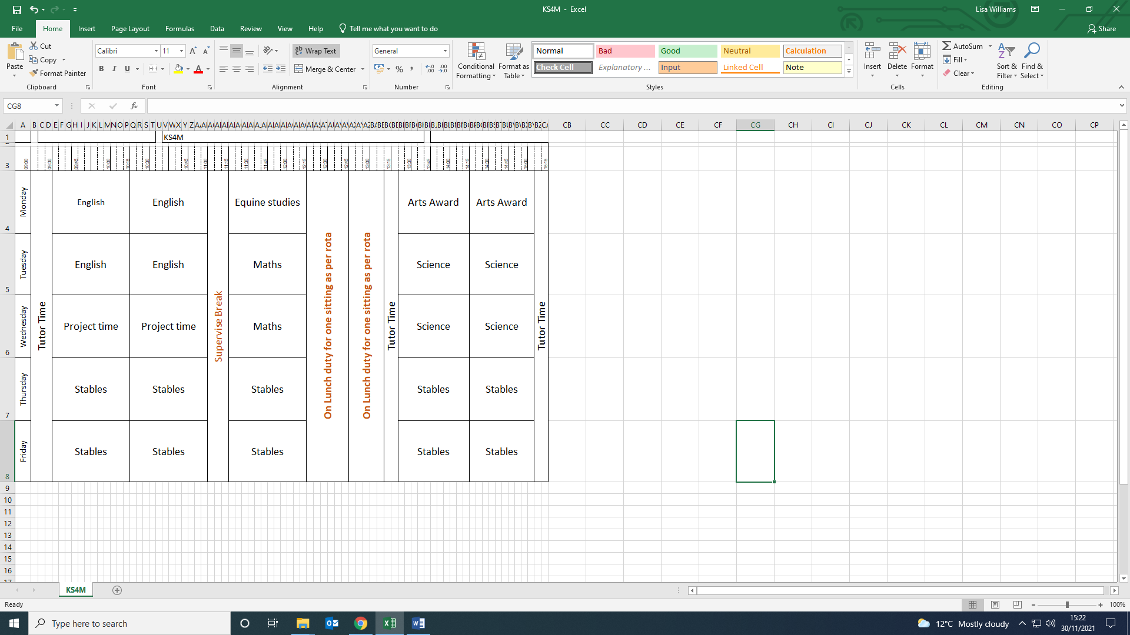

**English.** The students are reading, The Curious Incident of the Dog in the Night Time, expanded with comprehension and discussion.

**Topic work,** students have chosen a subject from a range of ideas and are following the criteria set out for them, highlighting facts, opinions, statistics etc.

**Maths**. Understanding and using 2D shapes. Students are identifying and using correct vocabulary and terminology relating to the properties of 2D shapes. This includes, naming, calculating and naming angles, symmetry and complex tessellation.

**Science.** Variation and adaptation in the environment. Students are learning how various plant/animals adapt to their environment. They are outlining the natural and external factors that affect the growth and stability of the species. They will cover the evolution of an animal of their choice and create a poster/pamphlet highlighting this.

**Art.** Students are continuing their portfolio work for the Bronze Art Award. This term they are focussing on exhibitions and research.

There work will be supported with educational visits within the local community and trips to the Botanical Gardens and Sea life centre.