
Class: KS5LM
Summer Term Overview
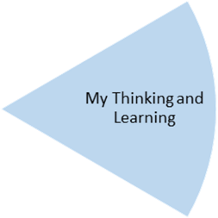
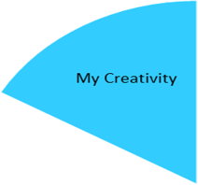

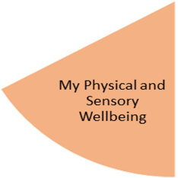
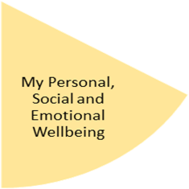
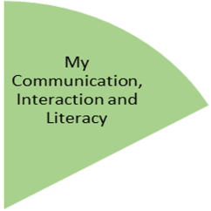
Students will take part in Volunteering opportunities at Welcome Change, and horticulture sessions internally, and will practice how to maintain a garden, and how to grow vegetables and flowers.
Students will focus on the expedition section of their Duke of Edinburgh award, practicing skills for putting up tents, using a map, and cooking outdoors.

Students will explore how to keep themselves healthy during the summer, including creating lists of things that they would need to take with them for summer days out, and packing their own bags with these items for community access visits.
Students will take part in sports and games, including tennis, team games and crazy golf in the garden and local parks.

Students will take part in picnics in different outdoor venues and will plan their picnic, visit the shop to buy the things that they need, then make their picnic to take with them.
During community access students will spot hazards that are related to summer and discuss who they could contact if they needed help.
During community access visits to cafes and leisure facilities, students will practice asking common questions to staff that work at the venues, to gain information or help.
Students will practice writing invites to parties, including summer garden parties. They will also practice writing letters of thanks.

My Independence
My Health and Wellbeing
Preparing for My Future
During community access students will find sculptures and use iPads to take photos of these. They will use their photos to create a photo book, and as inspiration for their own nature art piece. They will then collect natural items from parks and outdoor spaces to create their own nature art piece.

During community access students will visit a range of parks and outdoor venues and will spot hazards that are related to summer. They will then discuss who they could contact if they needed help, and whether the hazards that they spot would need reporting and who to report to.

My Physical and Sensory Wellbeing lessons, pupils will have the opportunity to discover and learn to self-regulate their sensory needs. Pupils will participate in a range of lessons such as PE, cooking and movement breaks to develop an awareness of their body, senses and further developing fine and gross motor skills under the thematic approach.

My Community and Wider World
lessons, pupils will have the opportunity to explore the world around them through forest school and trips to places outside of school to build up engagement under the thematic approach.

My Creativity lessons are based around child-led activities giving pupils the ability to explore their creativity and develop engagement through art, music, and open theatre under the thematic approach.

