
Class: Zephaniah
Summer Term Overview
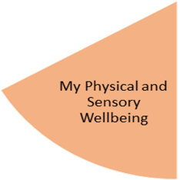
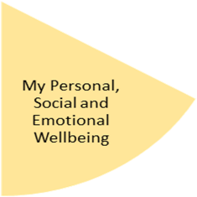
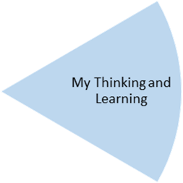
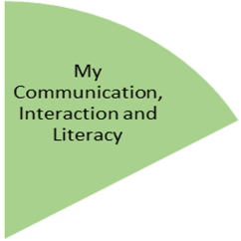
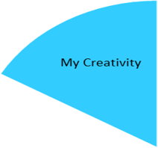
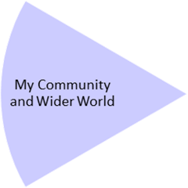
Students will read ‘The Boy in The Striped Pyjamas’. They will carefully and sensitively explore the themes within the book through a range of reading, writing and speaking and listening activities. Lower ability students will work in a smaller group and read Mr Stink by David Walliams. Some students are taking part in social and communication groups and also Lego Club to develop their communication skills.

My Physical and Sensory Wellbeing lessons, pupils will have the opportunity to discover and learn to self-regulate their sensory needs. Pupils will participate in a range of lessons such as PE, cooking and movement breaks to develop an awareness of their body, senses and further developing fine and gross motor skills under the thematic approach.

My Community and Wider World
lessons, pupils will have the opportunity to explore the world around them through forest school and trips to places outside of school to build up engagement under the thematic approach.

My Creativity lessons are based around child-led activities giving pupils the ability to explore their creativity and develop engagement through art, music, and open theatre under the thematic approach.

PE: Students will students will learn orienteering, map reading and teamwork.
In addition to this ,their will be a stunning starter and fabulous finish to focus on this area.

Food: Students will be following Food: A Fact of Life. Healthy Eating programme. Students will learn about healthy eating, the Eatwell Guide and the importance of being active. They will prepare a range of healthy meals and snacks.
Science: Students will continue their study of electricity and magnetism learning about their effects and uses, and the links between the two.
Mathematics: students will apply decimals in the context of money and interpret data though a range of statistical measures.
Computing: In this unit the students will extend their drawing skills to create 3D models based on using the software SketchUp. Students will learn how to create simple and complex 3D models. They will be able to add detail and manipulate 3D models using a variety of tools.

In PSHE, students will explore real-life issues and how they can recognise and deal with them appropriately. This half-term students will focus on relationships, and the sensitive issues of domestic violence and radicalisation. Throughout the half-term, students reflect on their progress towards achieving their personal targets linked to their EHCPs.

Art: The focus for students will sculpture, structure, inventiveness and determination. In this pathway children explore formal drawing and sculpture skills like line, mark making, shape, form, balance and structure, but they also just as importantly explore how it feels to make art. They explore how they can appreciate a sense of challenge, and a feeling of trying things out without fear of failure or “wrong or right”.
Music: our music sessions are delivered by Services for Education

Careers: Our Careers Advisor will continue to meet with our KS3 students. There will be opportunities to meet employers/ employees.
RE: Students examine the themes of Being open, honest and truthful; silent and attentive; courageous and confident; hopeful and visionary.
Outdoor Learning (John Muir): Students will continue to focus on conservation work.
History: Students will explore Australia, focusing on climate, population and culture. We will be exploring the aboriginal people and the importance of Uluru to them, then look at coastal features and the threats the Great Barrier Reef is facing.

