
Class: KS3Mead
Summer Term Overview
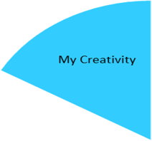
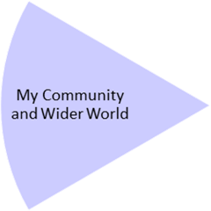
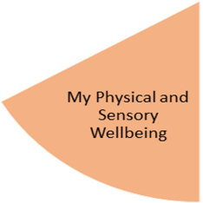
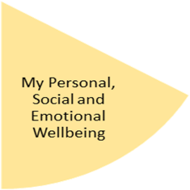
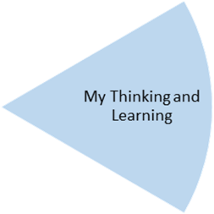
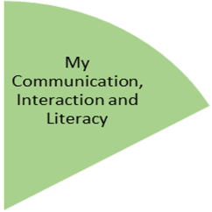
Pupils will have further developed their craft skills by using different materials to weave. Also furthering their textiles skills including sewing by learning cross stich.

Pupils will have attended Music lessons and Open Theatre delivered by an outside agency.

Pupils are going to experience learning outside the classroom by visiting the shops, places of worship, Think Tank and the local community.

They will also have access to Forest school at our Primary site with our new leader Elliot Lamber.

Students will explore different religions by experiencing their places of worship.

During leisure they will have experienced turn taking games, and for them to progress their independence skills we will be visiting the shops/ cafés.

Food technology students will explore and taste different foods from different cultures.

Pupils will have experienced a sensory story called, Around the World with Max and Lemon. They will also and have knowledge of the world map and looking at different countries and their climates. They will be asked if they can find the UK on the map and label the countries. They will focus on communication skills in our morning circle then bringing this into our sensory story to communicate what they each place is they are visiting, like and not like and what activities they want to do in the part of the story. They will also describe what animals live in each climate.

My Physical and Sensory Wellbeing lessons, pupils will have the opportunity to discover and learn to self-regulate their sensory needs. Pupils will participate in a range of lessons such as PE, cooking and movement breaks to develop an awareness of their body, senses and further developing fine and gross motor skills under the thematic approach.

My Community and Wider World
lessons, pupils will have the opportunity to explore the world around them through forest school and trips to places outside of school to build up engagement under the thematic approach.

My Creativity lessons are based around child-led activities giving pupils the ability to explore their creativity and develop engagement through art, music, and open theatre under the thematic approach.

Pupils will have experienced a range of fine motor skills by accessing our morning activities related to the topic. They will be using different tools to rip, pull, squeeze, and stir. We have been making henna tattoos, flower positions, smelling and cutting different herbs and picking out rubbish from the polluted ocean. These are all activities that students work together on using our tuff trays.

Use of sensory room and relaxation in the classroom to meet their sensory needs.

PE- Dance and Gymnastics.

In maths students will have gained the knowledge of ordinal numbers and position and direction. For ordinal numbers they will all have a number line and having students having to put themselves in the correct order with the number they have been given. For position and direction, they will be in groups where they have to follow instructions of which direction they are going and then have to verbally communicate this to their partners with the help and support of the teaching assistants.

In Science we will be looking at what helps a plant grow, planting different typed of plant and what equipment we need. Our Fabulous finish will be a trip to the Think Tank

