
Class: Ks3 Knight
Summer Term Overview
Theme - Let it grow.
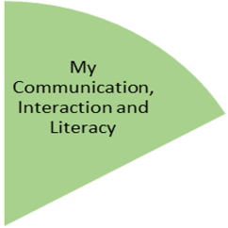
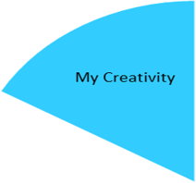
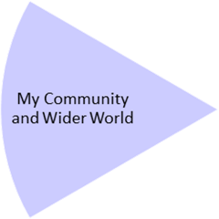
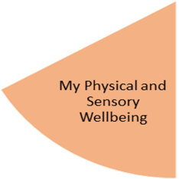
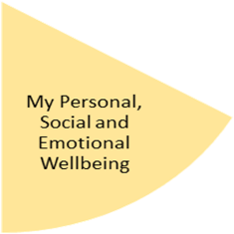
Pupils will have developed/ experienced a breath of vocabulary linking to flowers, vegetables, gardening, this will be explored through symbols and aided language displays used by pupils.
Through the term pupils will also choose and experience a range of sensory opportunities prompting engagement in a rotation with work-based activities, this includes water play, salt dough, massage, coloring, corn flour, reading and many more.

My Physical and Sensory Wellbeing lessons, pupils will have the opportunity to discover and learn to self-regulate their sensory needs. Pupils will participate in a range of lessons such as PE, cooking and movement breaks to develop an awareness of their body, senses and further developing fine and gross motor skills under the thematic approach.

My Community and Wider World
lessons, pupils will have the opportunity to explore the world around them through forest school and trips to places outside of school to build up engagement under the thematic approach.

My Creativity lessons are based around child-led activities giving pupils the ability to explore their creativity and develop engagement through art, music, and open theatre under the thematic approach.

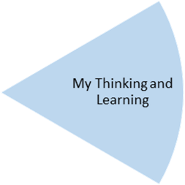
Pupils will have the opportunity to express themselves creatively during open theatre sessions. Develop independence skills needed for cooking. Pupils will also develop their printing and collage skills.

Pupils will continue to develop their clothes management skills, including folding and hanging clothes, using a washing machine, sorting items based on weather and simple shoe related skills.
Pupils will experience the process of growing their own food, they will then have the opportunity to prepare and try the different items they will be growing.

Pupils will have experienced and developed their fine and gross motor skills, completing activities design by an Occupational therapist. Pupils will also choose and experience a range of relaxation opportunities, including gardening, going for a walk, water play, foot spa, and many more.

Pupils will begin to recognise/experience the simple cycle of life, how things grow and develop, this is linked to both plants and food.
Pupils will also experience going out into the local community and develop vocabulary linked to the world around them, explored through symbols and aided language displays.

Pupil will experience gardening, develop skills and understanding of what a seed, bulb and flower needs to grow. They will use of simple ICT program, providing an opportunity to develop creativity using ICT. Pupils will continue to develop simple maths skills, through 1:1 learning opportunities.

