
Class: KS3 Harewood
Summer Term Overview
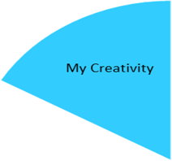
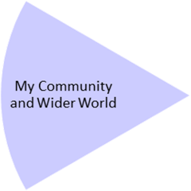
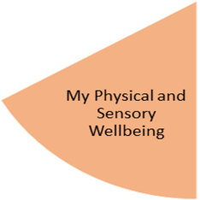
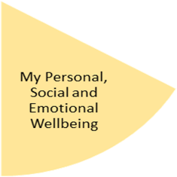
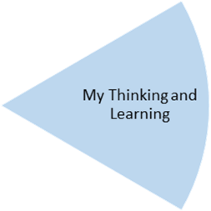
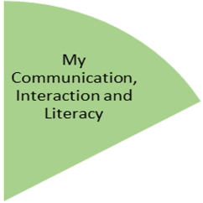
In PE, students will focus on catching and throwing, invasion games, and orienteering at Highbury Park. We will also continue to take part in the Daily Mile.
Through the topic of ‘Chocolate’ in English, students will practise using words ending in –sure and –ture, using and understanding context within pieces of text, and practise their handwriting. They will read Charlie and the Chocolate Factory and create work inspired by this story.

My Physical and Sensory Wellbeing lessons, pupils will have the opportunity to discover and learn to self-regulate their sensory needs. Pupils will participate in a range of lessons such as PE, cooking and movement breaks to develop an awareness of their body, senses and further developing fine and gross motor skills under the thematic approach.

My Community and Wider World
lessons, pupils will have the opportunity to explore the world around them through forest school and trips to places outside of school to build up engagement under the thematic approach.

My Creativity lessons are based around child-led activities giving pupils the ability to explore their creativity and develop engagement through art, music, and open theatre under the thematic approach.

In Art, the focus for students will be Sculpture, structure, inventiveness and determination. In this pathway children explore formal drawing and sculpture skills like line, mark making, shape, form, balance and structure, but they also just as importantly explore how it feels to make art. This will culminate in studying and building a sculpture of a birds next.
Within maths, students will practically explore different types of measurement. They will also use geometry skills to find positions and directions.
In computing, students will look at the technologies around us which form part of our daily lives.

In RE students will examine the themes of Being open, honest and truthful; Silent and attentive; Courageous and confident; Hopeful and visionary.
In Geography, Students will explore Australia, focusing on climate, population and culture. We will be exploring the aboriginal people and the importance of Uluru to them, then look at coastal features and the threats the Great Barrier Reef is facing.

In PSHE students will focus on relationships, and the sensitive issues of domestic violence and radicalisation.
Throughout the half-term, students will reflect on their progress towards achieving their personal targets linked to their EHCPs.

