
Class: KS4 Tolkien/Boulton
Summer Term Overview
English (Entry Level Certificate): The initial few weeks will include tasks to prepare students for their end of term assessments (Y10) and AQA qualifications 11.
Following this, they will be studying the topic of ‘Volunteering’: exploring different kinds of volunteering, writing email applications for volunteering using the appropriate formal language, considering the benefits of volunteering and what makes a good volunteer.
Open College Network: Students will focus on reading and recognising key words, signs and symbols in texts. In addition, they will be listening to others presentations while making the appropriate non-verbal responses.

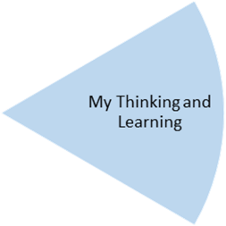
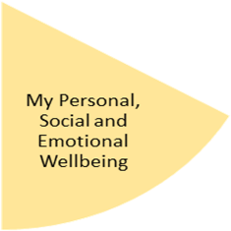
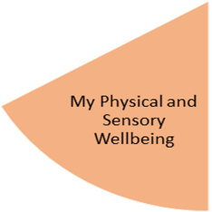
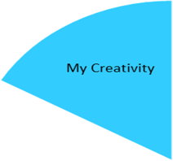
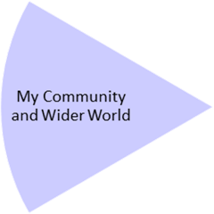
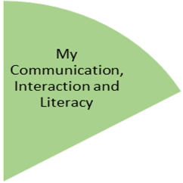
Mathematics (Entry Level Certificate): Set 1: Measures and Handling Data. Students will explore probability through practical experiments. They will also learn to manipulate algebraic terms. Set 2/3: The initial few weeks will include tasks to prepare students for their end of term assessments (Y10) and AQA qualifications 11. Following this, they will be carrying out Maths investigations , applying the skills they have learned in school and in the community.
Careers : Y11 students will be preparing for transition to their next educational stage. Y10 will continue to explore their future pathways, including discussing options with the school careers advisor.
Science (Entry Level Certificate): Set 1 & 2: exploring wavelengths, electric circuits and how forces interact. Set 3: will explore electricity and energy

Outdoor Learning: working towards Duke of Edinburgh Award. Activities to include venturing further afield to outdoor venues eg the Lickey Hills and Clent to develop map-reading and orienteering.
Beliefs and Values: Working towards ASDAN Humanities Award Y10/11: Crime and Punishment
Students will examine the important of rules and the Rule of Law, what constitutes a fair society, the harmful effects of bullying and discrimination and the consequences of civil and criminal offences.

PHSE: students will be learning about how to cope with friendship issues, including: making new friends in a new environment (transition), strategies for dealing with arguments and different opinions and relationships in the workplace
Food: Year 10 students will learn about personal hygiene, how to clean a kitchen and what products to use. They will design a label for a ready meal that needs to be stored in a refrigerator. It will include all the information to ensure product stays safe to eat.
Year 11 students will identify ingredients to make a simple dish and make it. Identify where and how different foods and drinks should be stored. They will identify main hazards associated with food and drink prep and conduct themselves safely in a kitchen.

Physical Education: Within their PE lessons, students will be engaging in two different types of activities and learning about the different skills in each activity. Outdoor & Adventurous Activities (orienteering, map reading, team work); Y11 Gymnastics & Dance (travelling, rolling, balancing, tempo, rhythm, sequencing & expression; Y10 PE Life Skills Award.

g.
Preparing for My Future
My Independence
My Health and Wellbeing
Art: Working towards the Bronze Arts Award
Y10: Collage from the Environment
Students will be using the natural world for inspiration to create collages, sculptures and other 3D artwork.
Y11: Students will be putting the final touches on their portfolio for submission for the Bronze Arts Award, including the teaching of an Arts-related skill to other students.

My Physical and Sensory Wellbeing lessons, pupils will have the opportunity to discover and learn to self-regulate their sensory needs. Pupils will participate in a range of lessons such as PE, cooking and movement breaks to develop an awareness of their body, senses and further developing fine and gross motor skills under the thematic approach.

My Community and Wider World
lessons, pupils will have the opportunity to explore the world around them through forest school and trips to places outside of school to build up engagement under the thematic approach.

My Creativity lessons are based around child-led activities giving pupils the ability to explore their creativity and develop engagement through art, music, and open theatre under the thematic approach.

