
Class: KS5LM
Spring Term Overview
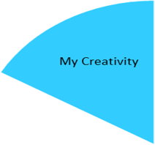
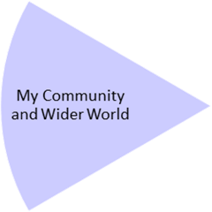
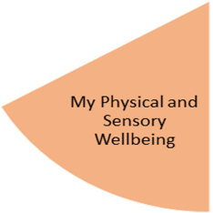
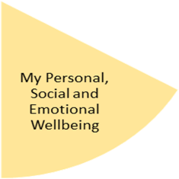
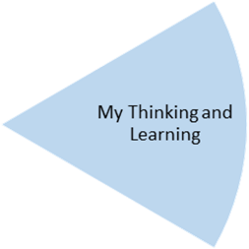
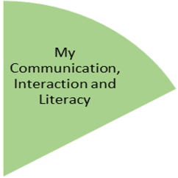
Community access:
world food supermarkets and cafes / restaurant
Bowling

Identify foods that might be included in a balanced diet
Identify benefits of healthy eating
Identify health problems linked to diet

My Independence
My Health and Wellbeing
Preparing for My Future
Famous artists from around the world
Explore painting styles from around the world
Create a world art painting

Make a range of drinks and snacks from around the world
Plan and prepare for a world food tasting event
Use timetables and lists to plan a trip to a restaurant
Develop stock taking and money skills in the snack shop
Take part in volunteering sessions
Developing reading skills:
To read menus, recipes and restaurant reviews.
To read information about foods from around the world

My Physical and Sensory Wellbeing lessons, pupils will have the opportunity to discover and learn to self-regulate their sensory needs. Pupils will participate in a range of lessons such as PE, cooking and movement breaks to develop an awareness of their body, senses and further developing fine and gross motor skills under the thematic approach.

My Community and Wider World
lessons, pupils will have the opportunity to explore the world around them through forest school and trips to places outside of school to build up engagement under the thematic approach.

My Creativity lessons are based around child-led activities giving pupils the ability to explore their creativity and develop engagement through art, music, and open theatre under the thematic approach.

