
Class: KS5E
Spring Term Overview
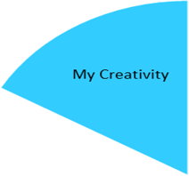

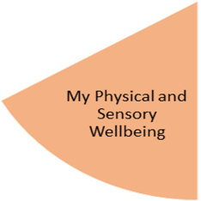
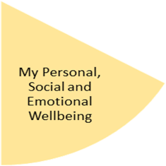
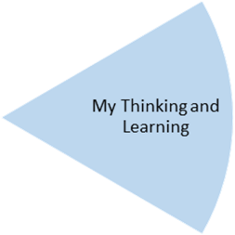
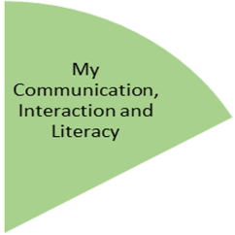
- To identify musical instruments and their sounds and state a preference.
- To produce musical sounds from an instrument.
- To look at different artist’s work
- To re create in the style of different artists

- Accessing a variety of leisure services – locally and further a field
- Visit different places to eat out and try a range of food from different cultures
- Visit different types of shops and know where to find certain items within a shop
- To make payments and to secure goods and change.

- To identify an area that requires cleaning e.g. because of a spillage, untidy and select and use appropriate products to clean different areas safely.
- To identify benefits of healthy eating and health problems linked to diet.
- To identify healthy cooking methods
- Being safe – including online safety
- Understanding consent in different situations
- To identify different exercise activities to participate in and clothing/footwear that is appropriate to wear.
- To identify some benefits and barriers for exercise
- To identify why clothes should be changed and washed regularly.
- To practice care routines

- To understand what money is used for and to identify and add coins.
- To practice retrieving and securing money in different purses/wallets
- To know and order days of the week, months of the year and seasons
- To tell the time – o’clock, half past, quarter past and quarter to
- To identify different jobs in the community
- To plan and prepare for a Spring fayre

- Communication – using key words in context – answering simple questions and requesting
- Reading – instructions, shopping lists, menus, sharing books.
- Writing – making a shopping list, instructions for a simple activity

My Independence
My Health and Wellbeing
Preparing for My Future
My Physical and Sensory Wellbeing lessons, pupils will have the opportunity to discover and learn to self-regulate their sensory needs. Pupils will participate in a range of lessons such as PE, cooking and movement breaks to develop an awareness of their body, senses and further developing fine and gross motor skills under the thematic approach.

My Community and Wider World
lessons, pupils will have the opportunity to explore the world around them through forest school and trips to places outside of school to build up engagement under the thematic approach.

My Creativity lessons are based around child-led activities giving pupils the ability to explore their creativity and develop engagement through art, music, and open theatre under the thematic approach.

