
Class: EYFS Robins and Otters
Spring 1 Term Overview
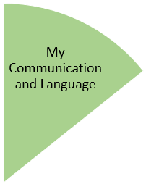
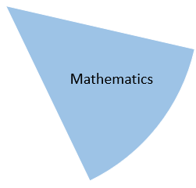
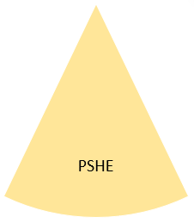
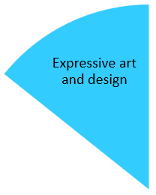
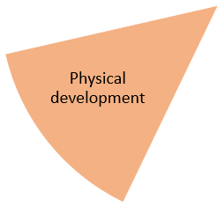
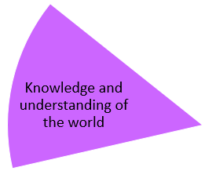
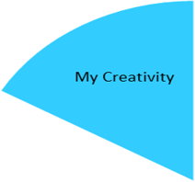
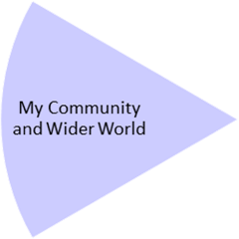
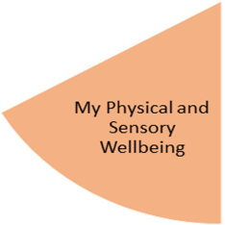
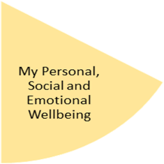
Ed will come into class for music every week and we will explore musical instruments.
The children will take part in a range of sticking and painting activities related to “buildings”, including using different textures and see-through materials.

The children will work on using photo choice boards to communicate to an adult what toy or food item they want.
The children will work on rhymes and vocab related to our “buildings” topic through the literacy circle and individual work trays.

The children will explore natural materials, indoors and outside.
They will experience Little Forest School and outdoor learning activities related to our topic of “buildings”.
The children will explore a variety of construction and texture activities. They will work on some simple games in PE. They will continue to work on fine motor and mark-making skills.

The children will continue working on following visual timetables.
They will attend small group, shared attention circles and work on turn taking with visual support.

The children will continue working on understanding “finished” and completing individual work trays. They will work on number rhymes relating to our topic of “buildings”. They will do some work on big and little, sequencing numbers and some work on tall and short.
My Physical and Sensory Wellbeing lessons, pupils will have the opportunity to discover and learn to self-regulate their sensory needs. Pupils will participate in a range of lessons such as PE, cooking and movement breaks to develop an awareness of their body, senses and further developing fine and gross motor skills under the thematic approach.

My Community and Wider World
lessons, pupils will have the opportunity to explore the world around them through forest school and trips to places outside of school to build up engagement under the thematic approach.

My Creativity lessons are based around child-led activities giving pupils the ability to explore their creativity and develop engagement through art, music, and open theatre under the thematic approach.

