
Class: Gruffalo
Spring Term Overview
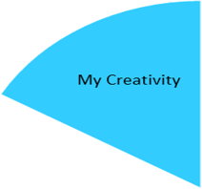
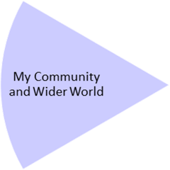
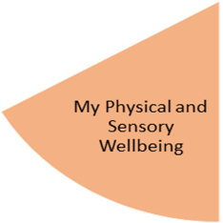
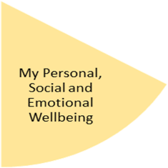
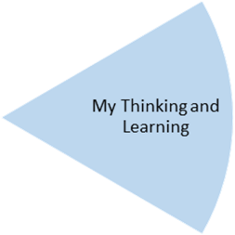
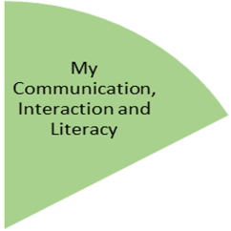
Throughout the spring term: Once a week the Gruffalos will go to the local park, and we will investigate the appropriate clothing to match the weather. Linking our work from PSHE we will be visiting a local dentist within our community, having the opportunity to see what might happen when at the dentist. Linking work to science and topic theme “wonderful weather” children will potentially visit the snow dome to explore snow and clothes we may wear in cold/wet conditions.
Throughout the spring term: Children will participate in painting, printing, sticking, and exploring natural materials. All activities are liked to weather, developing their skills such as using tools with a purpose, painting within an outline and having the opportunity to make choices of colour, tools, and materials.
Children will attend weekly sessions of Open theatre and music.

Throughout the spring term: We are participating in dance, we will be listening and moving our bodies to different types of music and exploring fast, slow, and relaxing generous. At the end of the term, we aim to introduce props into our dance. Day to day we will participate in movement breaks to support our sensory needs and gross motor skills.
Throughout the spring term: Our focus in PSHE is linked to “A healthy me”, we will be focusing on teeth, how to clean our teeth, and healthy teeth, through play we are developing language and interaction surrounding teeth. All activities will support us for when we visit a local dentist at the end of the term.

Throughout the spring term: in Numeracy the Gruffalos will be working on 1:1 correspondence. Being able to transfer /have the opportunity to use this skill in other areas of the curriculum. In science, we will be exploring the change in materials from solid to liquids, wet and dry, and hot and cold. And in ICT, children will participate in exploring different apps linked to the weather.
Throughout the spring term, Gruffalos will work on recognising vocabulary linked to clothing and work on “giving” a photo or symbol supporting 1-2 information-carrying word/s to develop communication.
We will continue working on communication throughout all areas of the curriculum.

My Independence
My Health and Wellbeing
Preparing for My Future
My Physical and Sensory Wellbeing lessons, pupils will have the opportunity to discover and learn to self-regulate their sensory needs. Pupils will participate in a range of lessons such as PE, cooking and movement breaks to develop an awareness of their body, senses and further developing fine and gross motor skills under the thematic approach.

My Community and Wider World
lessons, pupils will have the opportunity to explore the world around them through forest school and trips to places outside of school to build up engagement under the thematic approach.

My Creativity lessons are based around child-led activities giving pupils the ability to explore their creativity and develop engagement through art, music, and open theatre under the thematic approach.

