
Class: Bears
Spring Term Overview
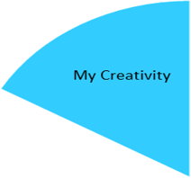

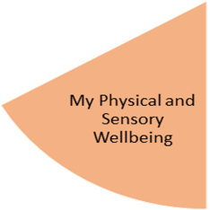
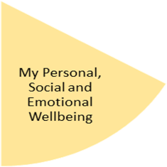
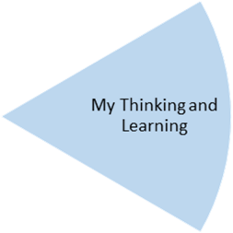
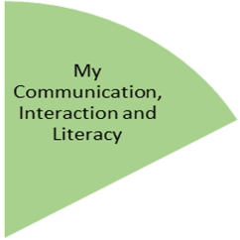

We will be developing our knowledge of gymnastics, looking at different types of travelling, balancing and moving with increased control and co-ordination on the apparatus.

In maths, we will be focussing on measure, linking this to making a rain catcher in ‘My Creativity’. They will look at how to read measurements, as well as performing calculations involving measures. We will learn about different types of weather, including extreme weathers and materials that are suitable for different weather conditions.

My Independence
My Health and Wellbeing
Preparing for My Future
In order to measure the weather, we will be making our own rain catchers and recording the rainfall over a period of time. We will also be designing and making a kite, looking at suitable materials and the best weather conditions to test the kites.

Children will be looking at weather patterns in the UK and comparing these with other countries. We will notice environmental changes throughout the seasons and look at how extreme weathers can affect communities, including what we can do to help.

This half term, the theme is ‘Healthy Me’ and will cover topics such as personal hygiene, including hand hygiene, knowing how to keep their minds and bodies healthy, as well as being aware that some household substances (disinfectant, medicines) can be harmful when not used correctly.
Over the course of the half term, children will experience fiction, non-fiction and poetry related to the theme of ‘Wonderful Weather’. Children will produce pieces of writing linked to these areas. We will be looking at writing verbs in the correct tense and singular and plural nouns.

My Physical and Sensory Wellbeing lessons, pupils will have the opportunity to discover and learn to self-regulate their sensory needs. Pupils will participate in a range of lessons such as PE, cooking and movement breaks to develop an awareness of their body, senses and further developing fine and gross motor skills under the thematic approach.

My Community and Wider World
lessons, pupils will have the opportunity to explore the world around them through forest school and trips to places outside of school to build up engagement under the thematic approach.

My Creativity lessons are based around child-led activities giving pupils the ability to explore their creativity and develop engagement through art, music, and open theatre under the thematic approach.

