
Class: KS3 Main
Spring Term Overview
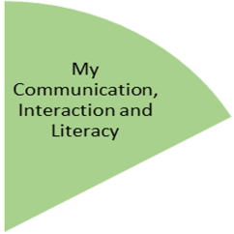
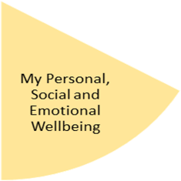
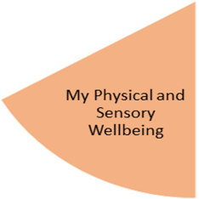
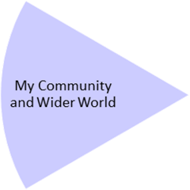
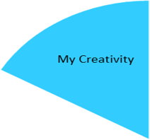
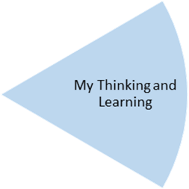
This segment will be our main focus for this half term, we will encourage independence in the pupils and help them to develop and practise life skills.
DT Food – pupils will name a food/meal they like to eat at home, list ingredients they need, shop for these (during school time) and then make said item.
Science – pupils will continue to study Biology with a focus on reproduction in animals (including humans) and plants.
Computing – life skills pupils can use in the future – such as researching transport links and timetables, using maps to find directions to new places, visiting websites to find opening times etc.
Maths – pupils will cover a range of topics in Maths – with a particular focus on when/where these skills can be used in real world situations where appropriate.
Cadbury and Harewood - Number – division, place value, fractions. Measurement – length and height. Geometry – shape. Handling Data – statistics
Zephaniah - Number – multiplication and division, place value, fractions and decimals. Measurement – length, perimeter and area, mass and capacity

Art – the focus for pupils will be The Art of Display. Pupils will be learning about famous plinths and sculptors with a view to creating their own art to display!
Music - Services for Education

Careers – conversations with the careers advisor where appropriate.
RE – Being fair and just, being accountable, remembering roots being loyal and steadfast
Geography – China
Outdoor Learning – continuing to assist staff at Highbury Hall to maintain the grounds.

PE – Pupils will be engaging in three different types of sports this half term and learning about the different movements involved in each.
Gymnastics – movement, balance & rolling
Dance – rhythm, emotions & tempo
Health Related Exercise (HRE) – resistance, using weights, outdoor fitness
PSHE – again a focus on real world issues and how pupils can recognise and deal with these - drugs, body image, radicalisation, trafficking.
English – each class will focus on different topics practising various grammar skills and writing styles:
Cadbury - Zoo (connectives, suffixes, inferences, tenses)
Harewood - Kings, Queens and castles (complex sentences, dictionaries, features of fiction, drafting and amending)
Zephaniah - Dragons (clauses and connectives, homophones, writing styles/diary entry).
Preparing for My Future
My Physical and Sensory Wellbeing lessons, pupils will have the opportunity to discover and learn to self-regulate their sensory needs. Pupils will participate in a range of lessons such as PE, cooking and movement breaks to develop an awareness of their body, senses and further developing fine and gross motor skills under the thematic approach.

My Community and Wider World
lessons, pupils will have the opportunity to explore the world around them through forest school and trips to places outside of school to build up engagement under the thematic approach.

My Creativity lessons are based around child-led activities giving pupils the ability to explore their creativity and develop engagement through art, music, and open theatre under the thematic approach.

