
Class: Ks3 Knight
Spring Term Overview
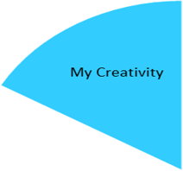
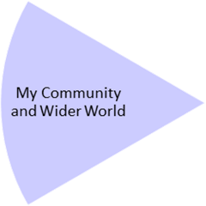
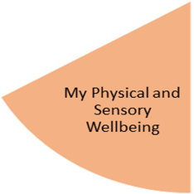
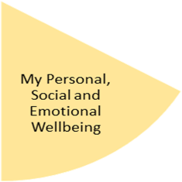
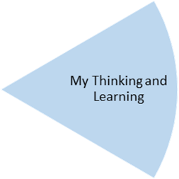
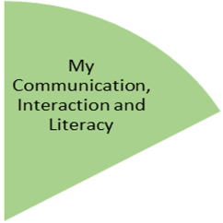
My Independence
My Health and Wellbeing
Preparing for My Future
By the end of this topic...
Pupils will have opportunities to express their creativity and experience using water colours. Pupils will make choices, follow sequences, and develop independence skills.

By the end of this topic….
Pupils will experience tasting, explore, and preparing different fish-based dishes, simple links to different cultures. Pupils will experience learning beyond the classroom.

By the end of this topic…
Pupils will have experienced and developed their fine and gross motor skills. Pupils will also experience a range of relaxation opportunities.

By the end of the topic…
Pupils would have experienced real life shopping, developing responsibility for money, and caring for a pet.

By the end of the topic …
Pupils will have developed the skills to experience visiting the Sealife centre safely. Pupils will experience and gain knowledge of different animals their habitat.

By the end of the topic…
Pupils will have experienced a range of non-fiction song/ books about sea animals, expanding their vocabulary. In relations, working on simple ‘wh’ questions and concepts.

My Physical and Sensory Wellbeing lessons, pupils will have the opportunity to discover and learn to self-regulate their sensory needs. Pupils will participate in a range of lessons such as PE, cooking and movement breaks to develop an awareness of their body, senses and further developing fine and gross motor skills under the thematic approach.

My Community and Wider World
lessons, pupils will have the opportunity to explore the world around them through forest school and trips to places outside of school to build up engagement under the thematic approach.

My Creativity lessons are based around child-led activities giving pupils the ability to explore their creativity and develop engagement through art, music, and open theatre under the thematic approach.

