
Class: Priestly
Spring Term Overview
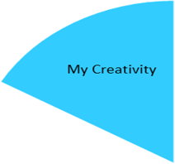

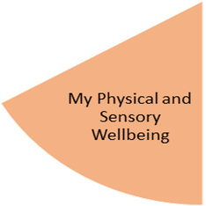
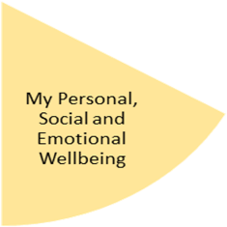
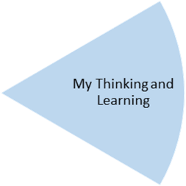
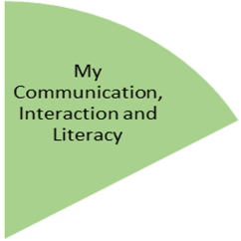
My Health and Wellbeing
Our Wonderful Weather Topic will be providing the inspiration for pupils to practise and develop a range of techniques including collage.
Pupils will also access weekly music and open theatre.
Pupils will take part in weekly Forest school sessions and also have opportunities for shopping trips, specifically linked to other curriculum areas.
Our weekly assemblies give the pupils opportunities to learn about the wider world and celebrate each other’s achievements.

Pupils will be taking part in Gymnastics sessions focusing on movement, balance & rolling. In Dance sessions the focus will be rhythm, emotions & tempo.

Pupils will continue to develop skills in turn taking and working with others. A particular focus will be on laundry and all the skills required to successfully use a washing machine. Within their Design Technology lessons, pupils will have the opportunity to explore fine motor skills when creating a piece of stitch craft.
Within their My Thinking and Leaning lessons, pupils will have the opportunity to explore Science, Mathematics and Computing under the thematic approach of Wonderful Weather. Pupils will discover weather changes within their Science lessons, Mathematics will focus on measuring and number, and pupils will be developing their research skills when looking at weather forecasts in Computing.

Science? Maths? Computing?

Our Wonderful Weather Topic will provide functional opportunities to develop links between reading and writing, speaking, listening and first-hand experiences through interaction. Pupils will identify different weathers and create a weather forecast.

My Physical and Sensory Wellbeing lessons, pupils will have the opportunity to discover and learn to self-regulate their sensory needs. Pupils will participate in a range of lessons such as PE, cooking and movement breaks to develop an awareness of their body, senses and further developing fine and gross motor skills under the thematic approach.

My Community and Wider World
lessons, pupils will have the opportunity to explore the world around them through forest school and trips to places outside of school to build up engagement under the thematic approach.

My Creativity lessons are based around child-led activities giving pupils the ability to explore their creativity and develop engagement through art, music, and open theatre under the thematic approach.

