
Class: KS3Mead
Spring Term Overview
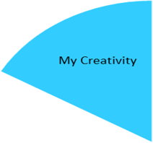
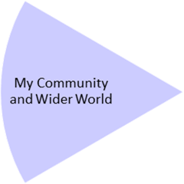
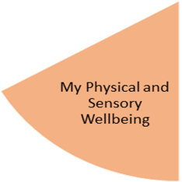
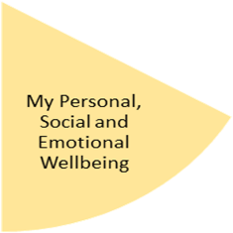
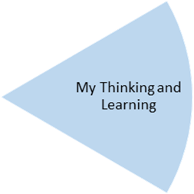
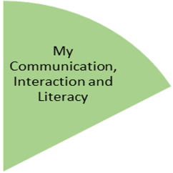
By the end of the topic—
Pupil’s will have further developed their cutting and sticking skills by creating a range of collages based on the theme of healthy eating in PSHC and Cooking for life and also materials in science.

Pupil’s will have attended music lessons and Open Theatre, delivered by an outside agency.

By the end of the topic—
Pupils will have experienced a range of fine and gross motor skills by learning how to use their bodies through dance using rhythm, and tempo and incorporating emotions. They will also be able to have gained skills in movement, balance & rolling within Gymnastics.
Used sensory room and relaxation in classroom to understand what relaxation is and meet their sensory needs.

My Independence
My Health and Wellbeing
Preparing for My Future
By the end of the topic—
Pupils will have developed how to take care and look after their clothes.
Pupil’s will have experienced learning outside the classroom through forest school sessions, visiting the shops, visiting local community

By the end of the topic—
Pupils will have a good knowledge of how to stay healthy and understand healthy and unhealthy foods.
Pupils will have experienced turn taking games, visiting the shop/ cafe, independent living skills and cooking for life.

By the end of the topic—
Pupil’s will identify a range of different materials and be able to use the correct vocabulary to describe them.
Pupil’s will have developed their knowledge of 2d and 3d shapes and recognize them in the environment.

By the end of the topic—
Pupils will have gained the sill to correctly form a sentence using capital letters and full stops. They will also be able to identify different weathers and create a weather forecast. We will also be looking at the book ‘All about the weather’.

My Physical and Sensory Wellbeing lessons, pupils will have the opportunity to discover and learn to self-regulate their sensory needs. Pupils will participate in a range of lessons such as PE, cooking and movement breaks to develop an awareness of their body, senses and further developing fine and gross motor skills under the thematic approach.

My Community and Wider World
lessons, pupils will have the opportunity to explore the world around them through forest school and trips to places outside of school to build up engagement under the thematic approach.

My Creativity lessons are based around child-led activities giving pupils the ability to explore their creativity and develop engagement through art, music, and open theatre under the thematic approach.

