
Class: Henry
Spring Term Overview
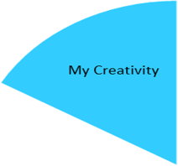
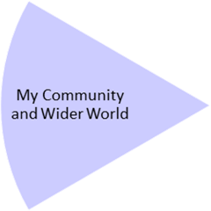
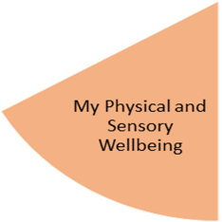
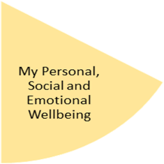
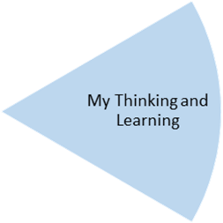
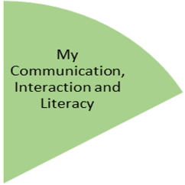
My Independence
My Health and Wellbeing
Preparing for My Future
Pupils will create a collage picture book, linked to people who help us. They will have the opportunity to mix paint with different materials and copy a modelled 2d picture.

Pupils will experience tasting, explore, and preparing different dishes with simple links to different seasons. They will also experience learning beyond the classroom at Forest Schools and making suitable clothing choices.

Pupils will experience and develop their fine and gross motor skills. They will also experience a range of relaxation opportunities. PE will involve:
Gymnastics – movement, balance & rolling
Dance – rhythm, emotions & tempo

Pupils will have the opportunity to set up a fruit shop to be set up in the classroom. They will experience the opportunity of buying items from the fruit shop and develop skills such as turn taking, using money and communicating their needs.

(Waiting for a turn, using money, communicating wants.)

Pupils will experience and gain knowledge of different materials and their properties, exploring and observing through sensory opportunities. They will also explore using laptops and will be accessing particular features.

Pupils will have experience a range of non-fiction song/ books about the weather, expanding their vocabulary. Additionally, working on simple ‘wh’ questions and concepts.

My Physical and Sensory Wellbeing lessons, pupils will have the opportunity to discover and learn to self-regulate their sensory needs. Pupils will participate in a range of lessons such as PE, cooking and movement breaks to develop an awareness of their body, senses and further developing fine and gross motor skills under the thematic approach.

My Community and Wider World
lessons, pupils will have the opportunity to explore the world around them through forest school and trips to places outside of school to build up engagement under the thematic approach.

My Creativity lessons are based around child-led activities giving pupils the ability to explore their creativity and develop engagement through art, music, and open theatre under the thematic approach.

